Il Gambero Function Menu 2023 / 2024

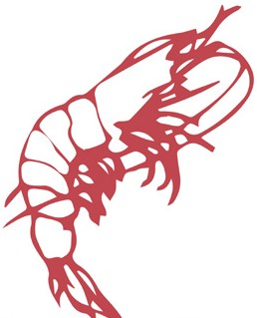Il Gambero Special
$30 Pizza and Pasta Menu (served banquet style to share)
Assorted Pizzas (one large pizza per 3 guests)
Mixed Pasta Platters (one platter per 3 guests) for gnocchi or seafood add $3
………………………………………………………………………………………………………………………….

Pricing for set menus
2 Courses $48 (pasta platters for entrée and choice of 2 mains alternate drop)
2 Courses $50 (choice of entrée/main OR main/dessert)
3 Courses $60 (entrée/main/dessert)
…………………………………………………………………………………………………………………………….

Entrée (Choose 2 alternate drop)
Fried Calamari (GF available)
Pasta – Penne: Bolognese, Napoli (V) or Carbonara
Traditional Meat Lasagna or Eggplant and Leek lasagna (V)
Nonna’s Meatballs (3)
Arancini (3) (V)

Mains (Choose 2 alternate drop)
Chicken Romana w mushroom sauce or Chicken Parmigiana (GF)
Scalloppine Al Nord Veal w olives, semi dried tomatos and capsicum (GF)
Fish of the day (Barramundi or Salmon) served w salad
Porterhouse Steak (200g) cooked medium w pepper or mushroom sauce (GF)
Vegetarian Risotto or Vegetarian pizza (V) (GF options)

Desserts (Choose 2 alternate drop)
Tiramisu
Chocolate Mousse (GF)
Vanilla Bean Pannacotta (GF)
Sticky Date Pudding w Butterscotch sauce
Mixed Gelati – Lemon (GF), Chocolate and Strawberry
…………………………………………………………………………………………………………………...

Extras
Garlic and Herb Focaccia Bread $4 per person (1 large per 4 people)
Hand Cut Chips or Fries (V) $3 per person (1 bowl per 4 people)
Italian Salads (V, GF) $3 per person (1 bowl per 4 people)
Mixed Green Vegetables (V) $5 (1 bowl per 4 people)
Soft Drink Jugs $4
Coffee and Tea (drip filter Coffee) $4

Cakeage - $2 per person to BYO cake (our staff to cut and serve)

